EXECUTIVE SUMMARY

Ampati pora Purakhasia Road (AP) do·a improvement, 20th km to 28th km, Meghalaya Logistics and Connectivity Improvement Project (MLCIP) corridor do·a, World Bank fund ka·se.
Meghalaya Logistics and Connectivity Improvement Project (MLCIP)

Submitted
to


Meghalaya Infrastructure Development Finance Corporation (MIDFC) Ltd.
House No. L/A-56, Lower Nongrim Hills,Top Floor,
Meghalaya Basin Development Authority (MBDA) Building,
Shillong East Khasi Hills, Meghalaya-793003

ESIA Somaning (Summary)

Project Rang·chanchapa (Project Introduction)
Meghalaya Logistics and Connectivity Improvement Project (MLCIP) an·chingni miksongrangko dakchakanina kam ka·a, chong·motgipa nangchongmot ong·a:
a) chin·apgipa road corridor-rangni jakkalna dal·gipa bikrang aro growth center-rangona connection-ko namatna; b) grong-level aro district-level logistics infrastructure aro seva-rangko namatna;
c) select agriculture aro horticulture product-rangna marketona reach ong·e jakkalna, cost aro samai-ko komiatna; aro d) East Meghalaya-o climate-resilient transport aro logistics-ko chusok ong·e chalna institution-rangni capacity-ko bilangna.
Ka proposed road Meghalaya state baje forming nakma somoi na chonak, ROW (Right of Way) nangni ka existing drain doa pura limited a·se. Ka proposed Ampati to Purakhasia project road ka total length 8.00 km a·se, Chopapara village do·a Chainage 20+000 a·se start chonak, Purakhasia village do·a Chainage 28+000 a·se end chonak, ni project road khangni chonak.
Niyam aro kanun-rang baksa meligrik ong·ani bynta
ESIA-ara ia niyam aro kanun-rang baksa meligrik ong·a:
- World Bank Environmental aro Social Framework (ESF)
- Environmental aro Social Standards (ESS 1–10)
- India Government aro Meghalaya Government-rang environmental niyam
- Labour, forest, biodiversity aro pollution control-rang kanun

Project-rang kam-chalna samai-suchi
Nang·ni set criteria aro conditions-rang baksa, MPWD civil works contract-ko eligible contractor-na debak ong·a. Contractor-na quality materials-ko pora jakkalna, nearest authorized source aro approved manufacturer-na laga debak ong·a. Construction process-rangni somai, prescribed standard-rang meet gipa equipment-ara use debak ong·a. Contractor-na construction schedule-rang baksa required manpower-ko mobilize debak ong·a. Ka 8.00 km project road construction period 24 months doa plan a·se.

Chong·ni pora environment-rang sthiti
Road corridor-rang soil sandy loam ong·a, well-drained aro moderately acidic ong·a, arangni region-rang high rainfall conditions-ina typical ong·a.
Water quality mostly fresh aro unpolluted ong·a, neutral pH-rang, sufficient dissolved oxygen-rang, low turbidity (monsoon-rang chadengsa except), aro low BOD/COD values ong·a. Industrial discharge nai, aro large-scale agricultural runoff-na water body-rang affect nai ong·a. Ning·a, ka groundwater quality satisfactory a·se ar ka drink ar domestic use do·a safe a·se.
Ambient noise environment mostly quiet to moderately noisy ong·a, rural area-rang characteristics-ina baksa. Baseline noise level-rang CPCB limit-rang residential aro rural area-rang somai, day aro night, most location-ona meligrik ong·a.
Project corridor-rang air quality good to moderate ong·a, rural Meghalaya-rang characteristic-ina, industrial activity kom ong·a. Ambient concentration PM₁₀, PM₂.₅, SO₂, NO₂, aro CO generally National Ambient Air Quality Standards (NAAQS)-na meligrik ong·a.
Environment aro community-rang upor project-rang potential effect
Ka proposed road corridor environment screening do·a, sensitive receptors ar community assets ka presence ka alignment do·a detect a·se. Ni ka include educational institutions: Government School do·a chainage 23+800 ar Primary School do·a chainage 25+850. Religious sites ka include church do·a chainage 25+200 ar another church do·a chainage 27+100. JJM (Jal Jeevan Mission) facility do·a chainage 25+300 ka note ka·se.

Adverse impact-rang komiatna aro project implementation smooth ong·a baksa, appropriate mitigation measures propose gipa ong·a. Ni observation aro recommendation-rang summary table-ona dekha gipa ong·a.

Table: Observation-rang aro Corresponding Recommendation-rang
Chainage | EIS Observation | Proposed Measures
20+500 | River bank do·a soil erosion observe ka·se | Riverbank do·a soil erosion ka·do·a protection work ka·se
21+200 to 21+300 | River bank LHS side do·a soil erosion observe ka·se | Riverbank LHS side do·a erosion protection work ka·se
22+600 to 23+920 | Road broken ka·se, improvement ka·do·a | -
23+200 | Culvert partially damaged ka·se | Culvert location do·a apron repair ka·se
23+800 | Government School do·a, speed reduction measure (20 KMPH) ka·do·a | Speed reduction measure ka·se
23+850 | Minor bridge abutment do·a erosion observe ka·se | Minor bridge abutment do·a erosion ka·do·a protection work ka·se
25+200 | Church, no impact ka·se | -
25+300 | JJM, no impact ka·se | -
25+480 | Big hole observe ka·se, repair ka·do·a | -
25+000 | Riverbank LHS do·a soil erosion observe ka·se | River training work ka·se to protect LHS soil erosion
25+300 | Curve observe ka·se | Minor bridge section do·a protection work ar curve improvement ka·se
26+600, 26+650 | Minor bridge | -
25+850 | Primary School, no impact ka·se | -
27+100 | Church, no impact ka·se | -
27+350 | Minor bridge, no impact ka·se | -
27+460 | Curve observe ka·se | Curve radius reduce ka·se to protect building structure
28+000 | Junction do·a traffic observe ka·se | Traffic islands provide ka·se for junction improvement

Community aro social-rang pora dekha gipa observation-rang

Social screening-rang finding-rang table-ona dekha gipa ong·a:

Social screening-rang dekha gipa observation aro result-rang
S. No. | LHS/RHS | Chainage and Distance | Distance from Centre Line (m) | Type of Impact
1 | RHS | 19+450 | 5.3 | Temporary shop (Shop ka temporary)
2 | LHS | 19+450 | 5.2 | House do·a bamboo fencing ka·se
3 | LHS | 23+100 | 5.4 | House do·a bamboo fencing ka·se
4 | LHS | 23+200 | 5.2 | House ar Community Hall ka·se
5 | RHS | 26+950 | 5.8 | Temporary shop (Shop ka temporary)

FPIC-2 Meeting Suggestions – Ampati–Purakhasia Road (APR)
Date: 6-10-2025
Time: 1:00 PM
Venue: Mebitpara Church Ground (Chainage update ka date: 14-10-2025)
S. No | Particulars/Village Name/Locality/Chainage | Suggestion/Query | Remarks | Compliance / Proposal in DPR
1 | Ch. 19+150 to 19+700 | Community do·a protection wall ka demand ka·se | Chainage update ka date: 14-10-2025 | Retaining wall Km 19+600 to 19+610 (LHS), Toe wall Km 19+640 to 19+650 (RHS)
2 | Ch. 20+000 | Community do·a houses protect ka·do·a retaining walls ka demand ka·se (road sides don·a) | Chainage update ka date: 14-10-2025 | Design do·a not required
3 | Ch. 19+500 | Community do·a landslide karon protection walls ka demand ka·se | Chainage update ka date: 14-10-2025 | Breast Wall Km 19+200 to 19+210 (LHS)
4 | All built-up areas | Community do·a wherever houses a·se, covered drain ka demand ka·se | Chainage update ka date: 14-10-2025 | Foot Path cum Drain Km 21+170 to 21+320 & Km 27+540 to 28+039
5 | Ch. 25+950 | Community do·a church protect ka·do·a protection wall ka demand ka·se | Chainage update ka date: 14-10-2025 | Complied, boundary wall DPR do·a provide ka·se
6 | Ch. 19+850 | Community do·a multipurpose community hall, bus waiting shed ar boys & girls separate toilet ka demand ka·se | Chainage update ka date: 14-10-2025 | Bus shelter & toilet proposed at Km 19+050
7 | Ch. 20+200 | Community do·a public water use ka spring chambers ka demand ka·se | Chainage update ka date: 14-10-2025 | Spring Chamber at Km 20+200 (RHS)
8 | Ch. 22+800 | Community do·a Sarv Shiksha Abhiyaan (SSA) School protect ka·do·a boundary wall ka demand ka·se | Chainage update ka date: 14-10-2025 | Boundary wall of 50m length at Km 22+800
9 | Ch. 23+035 | Community do·a bus shed ar boys & girls separate toilet ka demand ka·se | Chainage update ka date: 14-10-2025 | At Km 23+000 bus shed with repair works ar toilet proposed

GRM-rang process aro steps-rang diagrammatic representation
Nangni flowchart-rang show gipa ong·a two-tier grievance redressal mechanism, responsibilities aro resolution-rang timelines-rang baksa debak.
Project site-ona grievance redressal-rang baksa debak level | Responsibility: VECs & Headman  Timeline: Resolution within 15 days  If unresolved → Escalate to PMU (Tier II)
State level-ona, PMU-rang grievance redressal-rang baksa debak level | Responsibility: Secretary Planning, Chief Engineer,  Project Director, Social Expert  Timeline: Resolution within 15 days

Grievance Redressal Mechanism-rang process, responsibilities aro resolution-rang steps-rang baksa debak.
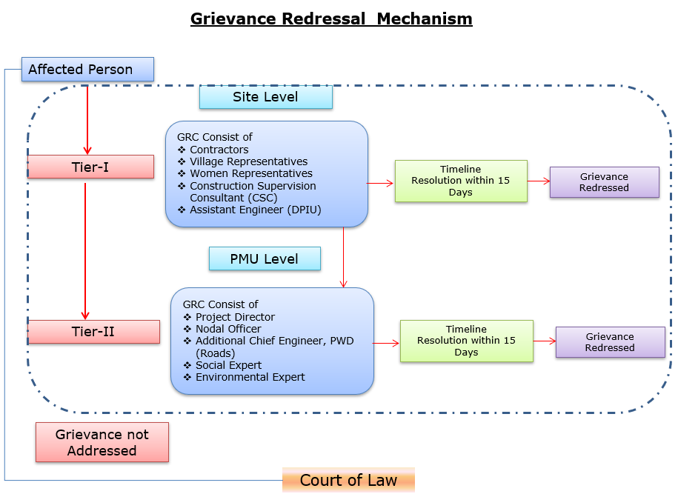
Grievances submit debak baksa contact information-rang baksa debak.
Baksa debak pora detail nai explanation | Baksa debak pora contact information, phone number, email, nai address
Company: | PWD, Meghalaya
To: | Chief Engineer-cum-Nodal officer
Address: | HV9P+GFJ, Lachumiere, Shillong, Meghalaya 793001
E-mail: | esmlcip@gmail.com
Website: | http://megpwd.gov.in/contacts.html
Telephone: | Tel: 0364-3572466
Fax: | -

Project-rang governance aro overall institutional structure-rang baksa debak.
Ka kam-rangkam ka dakgipa donggipa jylla Government of Meghalaya (GoM)-ni donggipa institutional architecture baksa meligrikgen, aro Sixth Schedule-ni niyam rangsani, janggi jatni hokrang (tribal autonomy)-ko dakchakgen.
MIDFC, je project-ni sabsi kamrangko dakchakgipa aro taka-paisani bynta nanggipa ong∙a, ua project-ni holder aro lead implementing agency ong∙gen.
MPWD-de civil works (rasta, bridge aro ropeway)-rangko dakchakgen, aro Department of Agriculture (DoA) aro MBMA-rangde agrologistics aro community components-rangko kam ka∙gen.
MIDFC-PMU-ni rangko project management aro coordination-rangko dakchakgen, World Bank-ni procedure-ko experience napha officers-ni through.
PMC, je team-ni expert aro consultant-rangni Team Leader-ni ong∙a dakchakgen, project activities-rangko technical support-ka∙gen, je implementing agencies-ni skill set-ni napha dang∙a.
CSC-ni construction supervision-ka∙gen.
PMC/CSC aro information collect aro document-ka∙gen-rangni aid ka∙gen.
Project implementation structure-ko figure-ni dang∙a dakchak:
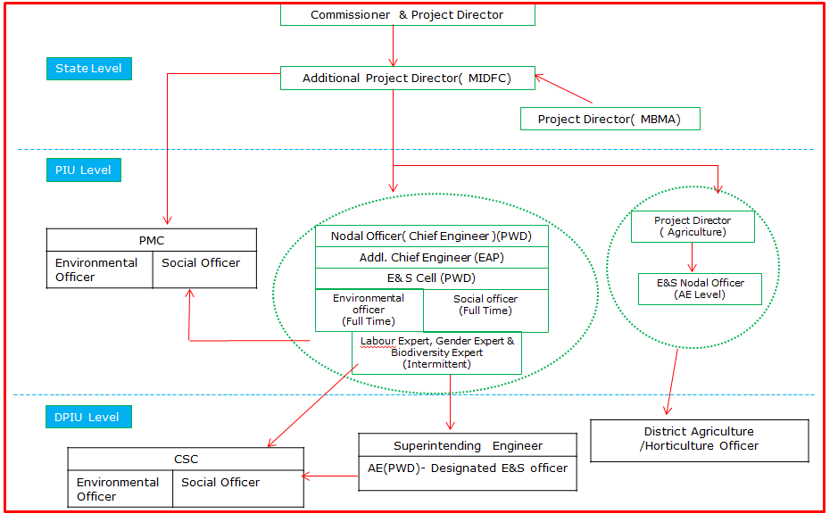
Figure: Project Kam-rangkam Organogram
Khutcha
ESIA-ni phayrang dakchakni phangni ni nangni gital:
• Proposed project-ni rasta-ni traffic flow-ni dakchakni aro motor vehicle aro pedestrian-ni safe aro smooth mobility-ka∙gen. Proposed road improvement-ni travel time-ni farthest section-ni rasta-ni dang∙a market-ni gi hour-ni 1 hako 30 minutes-ni mel∙a dakchak. Project-ni importance-ni trade aro commercial activity (public transport-ko include) East Garo Hills aro North Garo Hills-ni district-ni encouragement-ka∙gen.
• Environmental aro social impact assessment-ni World Bank ESF aro National & State regulations-ni meligrikgen. Pre-construction, construction aro operation phases-ni dang∙a potential impacts-ni dakchakni gital.
• Proposed project alignment-ni Wildlife Sanctuary/National Park/Biosphere Reserve/Tiger Reserve-ni dang∙a pasal-ni dakchak∙a.
• Project site-ni 0.5 km-ni dang∙a ASI Protected monuments-ni dakchak∙a.
• Approximately 20 trees existing Right of Way (RoW)-ni dang∙a road-ni sides-ni dakchakni. Tree felling-ni ecological impact-ka∙gen mitigation-ni, compensatory afforestation-ni applicable environmental regulations aro guidelines-ni meligrikgen dakchak∙a.
• Project road-ni construction activities-rangko environmental aro social impacts-ni dang∙a dakchakni; culturally important sites-ni proximity-ni (community center, church, school etc.) aro Project-Affected Persons (PAPs)-ni access-related issues-ni potential effect-ni dakchakni.
• Stakeholder Consultations-ni conducted dakchakni, proposed project-ni perception-ni assess-ka∙gen. Consultations-ni outcome-ni dakchakni, people-ni project-ni support-ka∙gen, karon road conditions aro connectivity-ni improve-ka∙gen. Tangni road safety measures; road furniture’s (streetlights, signage, speed breaker etc.) aro loss-of-assets-ni proper compensation-ni require-ni raised-ka∙gen.
• Occupational health aro safety measures-ni workers aro local community-ni ensure-ka∙gen, comprehensive Labour Management Plan (LMP)-ni prepare aro implement-ni through, World Bank Environmental and Social Standard ESS2 on Labor and Working Conditions-ni meligrikgen.
• Mitigation measures-ni environmental aro social monitoring-ni program-rangko construction aro operation phases-ni dakchakni assure-ka∙gen; implementation-ni confirm-ka∙gen aro environmental aro social conditions-ni stipulated or protected-ni check-ka∙gen. Observation on-site aro off-site, document check, workers aro beneficiaries-ni interview aro remedial action-ni requirement-ni contractor-ni MPWD-ni report-ka∙gen.
• ESMP-ni bidding document-ni include-ka∙gen, contractual clauses-ni project construction aro operation (maintenance period)-ni environment aro social impact safeguard-ni ensure-ka∙gen.
• Project-level aro construction stage-level Grievance Redress Mechanism (GRM)-ni form-ka∙gen, affected parties-ni feedback, suggestions aro complaints receive aro address-ka∙gen, construction aro operation stage-ni.
• Prepared ESMP-ni Contractor aro MPWD-ni assist-ka∙gen Environmental aro Social impacts mitigate-ka∙gen aro proposed project-ni environmentally sound execution-ni guide-ka∙gen.

Capacity building and training

Environmental aro Social Management Plan (ESMP)-ni implementation aro monitoring-ni capability-ni improve-ka∙gen, structured training programs-ni contractor aro project personnel-ni gi sabsi conduct-ka∙gen dakchakni recommend-ka∙gen.

Training-ni regulatory requirements-ni compliance ensure-ka∙gen, awareness improve-ka∙gen aro environmental aro social (E&S) risks-ni manage-ka∙gen competence build-ka∙gen.

On-Boarding Phase
a. Induction Training
• Sabsi personnel-ni work start-ka∙gen ni mandatory.
• Contractor-ni Environmental aro Social Management Plan (C-ESMP), relevant national aro international Environmental, Social, Health aro Safety (ESHS) regulations aro good practices-ni cover-ka∙gen.

b. Specialized Training

• Personnel-ni specific roles-ni (e.g., environmental officer, safety officer, waste management supervisor) assigned-ka∙gen tailored training.
• Mobilization stage-ni deliver-ka∙gen, assigned responsibilities-ni readiness ensure-ka∙gen.

Implementation Phase
- Ongoing Toolbox Talks:
Daily aro weekly conduct-ka∙gen, evolving risks address-ka∙gen, safety practices reinforce-ka∙gen aro workers-ni continuous awareness maintain-ka∙gen.
- Supplemental Training:
Incident-hako pare or new risks identify-hako pare provide-ka∙gen. Recurrence prevent-ka∙gen aro workforce-ni new safety/environmental requirements-ni updated rakha∙gen.
- Routine Quarterly Training:
Contractor-ni every three months organize-ka∙gen:
o E&S compliance status aro progress review-ka∙gen.
o Previous quarter-ni lessons learned share-ka∙gen.
o Identified gaps aro challenges address-ka∙gen action plans develop-ka∙gen.
o Sub-project E&S objectives-ni alignment ensure-ka∙gen aro continuous improvement promote-ka∙gen.

Outcomes of the stakeholders
Ampati–Purakhasia Road Meghalaya Logistics and Connectivity Improvement Project do·a FPIC process ka community engagement improve ka·se ar final consent ka·do·a achieve ka·se.
FPIC-I: Community ka project scope, potential impacts ar FPIC framework do·a inform ka·se. Land acquisition, tree felling, utility relocation, construction disturbances ar cultural/community assets protect ka·do·a concern ka·se. Project team ka assure ka·se ka minimal land acquisition ka·se, ESS7 compliance ka·se ar community inputs DPR ar ESMP do·a integrate ka·se. GRM committee formally establish ka·se.
FPIC-II: Community ka retaining walls, boundary walls ar other protective structures do·a detailed feedback ka·se. Project team ka commit ka·se ni suggestions DPR do·a include ka·se ar grievance lodge kar·do·a mechanisms community do·a share ka·se.
FPIC-III: Discussions labour camps ar community amenities do·a location plan ka·se. Community ka land provide ka willingness ka·se for boundary walls, community hall cum bus shelter ar boys & girls separate public toilets. Formal written consent ka submit ka·do·a ka·se. Joint site inspections plan finalization ka·se agree ka·se.
FPIC-IV: Project team updated design share ka·se, including new carriageway width 7.5 m ar retaining walls ar protective measures. Community ka minor concerns raise ka·se about additional earthwork ar hill/valley protection, ni address ka·se. Individual consent letters ar Nokma NOCs do·a clarification ka·se for affected properties.

Resettlement Action Plan (RAP)

Resettlement Policy Framework (RPF)-ni gi meligrik, project-ni social impacts avoid aro minimize-ka∙gen measures adopt-ka∙gen, careful design aro existing RoW-ni use-ka∙gen.
Continuous consultations conduct-ka∙gen aro functional GRM-ni ensure-ka∙gen, concerns-ni timely resolve-ka∙gen. Sabsi entitlements RPF-ni meligrik provide-ka∙gen.
Road section-ni identified impacts-ko basis-ni, detailed site-specific Resettlement Action Plan (RAP) prepare-ka∙gen, ha·ni final entitlements, mitigation measures, implementation arrangements aro monitoring framework outline-ka∙gen, aro civil works start-hako pare implement-ka∙gen.

